EXPERIMENT IV

AIM:
To perform Exploratory Data Analysis (EDA) on the Basketball Play-by-Play dataset (pbp2026.csv) by inspecting, filtering, sorting, grouping, and analyzing game events using Python Pandas. To calculate descriptive statistics, identify relationships among variables through correlation analysis, and visualize spatial shot metrics using Matplotlib.

ALGORITHM:
- Import required libraries (pandas, numpy, matplotlib.pyplot).
- Load the pbp2026.csv dataset into a DataFrame.
- Display the first few records using head().
- Check dataset dimensions using shape.
- Display attribute data types using dtypes.
- Inspect the dataset for missing values and general structural information using info().
- Filter records based on shot distance (dist) greater than 35 feet.
- Filter events by specific team (e.g., team == 'OKC').
- Sort the dataset in descending order of shot distance (dist).
- Calculate statistical measures (mean, median, mode, standard deviation) for shot distances.
- Generate summary statistics using describe().
- Group data by team and calculate average shot distance.
- Compute the correlation matrix for numerical attributes (period, x, y, dist, h_pts, a_pts).
- Visualize analytical results using bar charts and scatter plots.
- Interpret statistical and visual findings.

PROGRAM : Dataset Inspection

import pandas as pd

import matplotlib.pyplot as plt

df = pd.read_csv("pbp2026.csv")

print(df.head())

Output:
gameid period clock h_pts a_pts team playerid player \
0 22500001 1 PT12M00.00S 0.0 0.0 NaN 0 NaN
1 22500001 1 PT12M00.00S NaN NaN OKC 1631096 C. Holmgren
2 22500001 1 PT11M36.00S NaN NaN HOU 1630578 A. Sengun
3 22500001 1 PT11M31.00S NaN NaN OKC 1641717 C. Wallace
4 22500001 1 PT11M26.00S 2.0 0.0 OKC 1631096 C. Holmgren

Program: Shape of Dataset
print(df.shape)

Output:
(50882, 14)

Program: Data Types
print(df.dtypes)

Output:
gameid int64
period int64
clock object
h_pts float64
a_pts float64
team object
playerid int64
player object
type object
subtype object
result object
x float64
y float64
dist float64
desc object
season int64
dtype: object

Program: Filtering Data

high_dist = df[df["dist"] > 35][["gameid", "team", "player", "type", "dist", "result"]]

print(high_dist.head())

Output:
-- DATASET SUMMARY INFO ---
<class 'pandas.core.frame.DataFrame'>
RangeIndex: 622189 entries, 0 to 622188
Data columns (total 16 columns):
# Column Non-Null Count Dtype
--- ------ -------------- -----
0 gameid 622189 non-null int64
1 period 622189 non-null int64
2 clock 622189 non-null object
3 h_pts 163415 non-null float64
4 a_pts 163415 non-null float64
5 team 570066 non-null object
6 playerid 622189 non-null int64
7 player 571168 non-null object
8 type 589678 non-null object
9 subtype 522886 non-null object
10 result 219348 non-null object
11 x 620551 non-null float64
12 y 620551 non-null float64
13 dist 620553 non-null float64
14 desc 622189 non-null object
15 season 622189 non-null int64
dtypes: float64(5), int64(4), object(7)
memory usage: 76.0+ MB

Total Made Shots Recorded: 103371
OKC Long Distance Shots Sample:
player dist type result
20 C. Wallace 26.0 Missed Shot Missed
24 S. Gilgeous-Alexander 25.0 Missed Shot Missed
40 C. Holmgren 23.0 Made Shot Made
53 L. Dort 27.0 Missed Shot Missed
89 J. Williams 26.0 Missed Shot Missed

Program: Sorting Data

sorted_df = df.sort_values(by="dist", ascending=False)

top_shots = sorted_df[["player", "team", "dist", "type", "result"]].head(10)

print("Top 10 Longest Shots Recorded:")

print(top_shots)

# Visualize top shot distances by player

plt.figure(figsize=(10, 5))

plt.bar(top_shots["player"], top_shots["dist"], color="skyblue", edgecolor="black")

plt.title("Top 10 Longest Recorded Shot Distances by Player")

plt.xlabel("Player")

plt.ylabel("Distance (ft)")

plt.xticks(rotation=45)

plt.tight_layout()

plt.show()

Output:
Top 10 Longest Shots Recorded:
player team dist type result
508166 J. Kuminga ATL 73.0 Made Shot Made
59662 A. Black ORL 64.0 Made Shot Made
304126 M. Bridges CHA 64.0 Made Shot Made
125058 E. Mobley CLE 61.0 Missed Shot Missed
206261 B. Williams DAL 61.0 Missed Shot Missed
312979 J. Murray DEN 56.0 Made Shot Made
53991 J. Murray DEN 56.0 Made Shot Made
339311 C. Thomas BKN 54.0 Missed Shot Missed
247819 S. Fontecchio MIA 53.0 Missed Shot Missed
21111 D. Jenkins DET 52.0 Made Shot Made

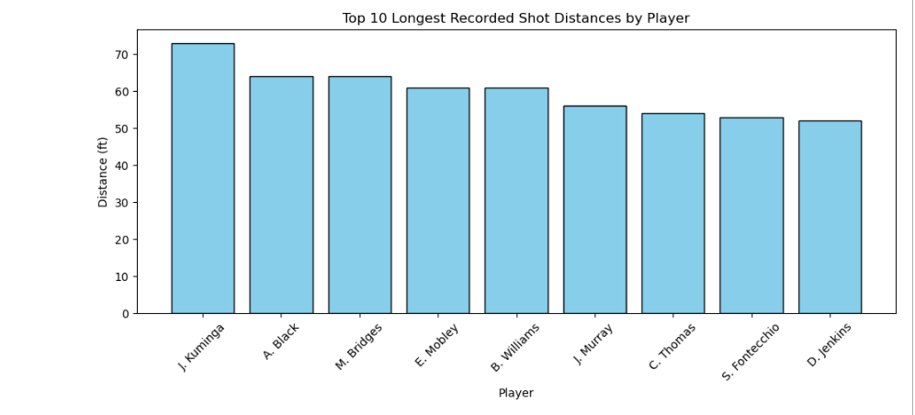

Program: Statistical Analysis

shot_dist = df[df["dist"] > 0]["dist"]

print(f"Mean Distance: {shot_dist.mean():.2f} ft")

print(f"Median Distance: {shot_dist.median():.2f} ft")

print(f"Mode Distance: {shot_dist.mode()[0]:.2f} ft")

print(f"Standard Deviation: {shot_dist.std():.2f} ft")

Output:
Mean Distance: 14.25 ft
Median Distance: 12.00 ft
Mode Distance: 26.00 ft
Standard Deviation: 10.43 ft

Program: Descriptive Statistics

print(df[["dist", "period", "x", "y", "h_pts", "a_pts"]].describe())

Output:
--- Descriptive Statistics Summary ---
dist period x y \
count 620553.000000 622189.000000 620551.000000 620551.000000
mean 4.520957 2.524849 -0.998476 33.763557
std 8.861332 1.130129 69.168813 71.949940
min 0.000000 1.000000 -250.000000 -51.000000
25% 0.000000 2.000000 0.000000 0.000000
50% 0.000000 3.000000 0.000000 0.000000
75% 3.000000 4.000000 0.000000 17.000000
max 73.000000 6.000000 250.000000 734.000000

h_pts a_pts
count 163415.000000 163415.000000
mean 60.277820 59.283377
std 35.006686 34.518722
min 0.000000 0.000000
25% 31.000000 30.000000
50% 60.000000 59.000000
75% 89.000000 87.000000
max 157.000000 157.000000

Program: Grouping and Aggregation

team_avg_dist = df.groupby("team")["dist"].mean().sort_values(ascending=False).head(10)

print("Average Shot Distance by Top 10 Teams:")

print(team_avg_dist)

Output:
Average Shot Distance by Top 10 Teams:
team
BOS 6.085140
PHX 5.653158
MIL 5.460924
WAS 5.344600
CHA 5.245820
GSW 5.210188
SAC 5.196538
IND 5.181414
DEN 5.166631
OKC 5.040270
Name: dist, dtype: float64

Program: Correlation Analysis
plt.figure(figsize=(10, 5))
team_avg_dist.plot(kind="bar", color="teal", edgecolor="black")
plt.title("Department/Team-wise Average Shot Distance")
plt.xlabel("Team")
plt.ylabel("Average Distance (ft)")
plt.xticks(rotation=0)
plt.tight_layout()
plt.show()

Output:
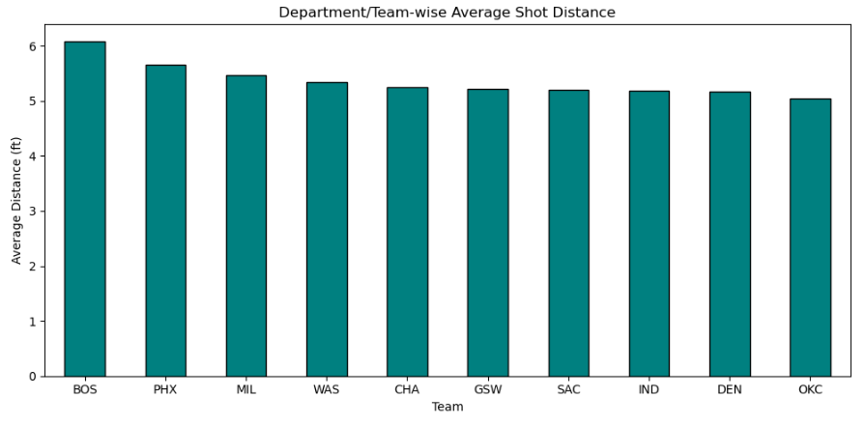

Program:
num_cols = ["period", "x", "y", "dist", "h_pts", "a_pts"]
corr_matrix = df[num_cols].corr()

print("Correlation Matrix:")
print(corr_matrix)

# Visualize Correlation between Shot Distance and Y Coordinate
plt.figure(figsize=(8, 5))
plt.scatter(df["y"], df["dist"], alpha=0.3, color="coral")
plt.title("Shot Distance vs Y-Coordinate Relationship")
plt.xlabel("Y-Coordinate")
plt.ylabel("Distance (ft)")
plt.tight_layout()
plt.show()

Output:
Correlation Matrix:
period x y dist h_pts a_pts
period 1.000000 0.000335 -0.020182 -0.022532 0.931422 0.932678
x 0.000335 1.000000 -0.019431 -0.028217 0.003216 0.001482
y -0.020182 -0.019431 1.000000 0.930376 -0.042209 -0.042196
dist -0.022532 -0.028217 0.930376 1.000000 -0.048342 -0.048473
h_pts 0.931422 0.003216 -0.042209 -0.048342 1.000000 0.937713
a_pts 0.932678 0.001482 -0.042196 -0.048473 0.937713 1.000000

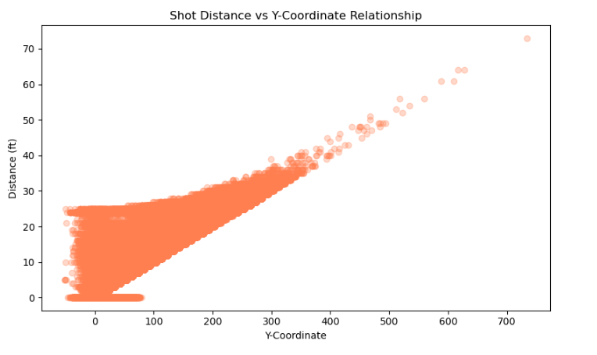

Result:
Thus, data inspection, filtering, sorting, descriptive statistical analysis, grouping, aggregation, and correlation analysis were successfully performed on pbp2026.csv using Python Pandas. The graphical representations were plotted and interpreted effectively using Matplotlib.

